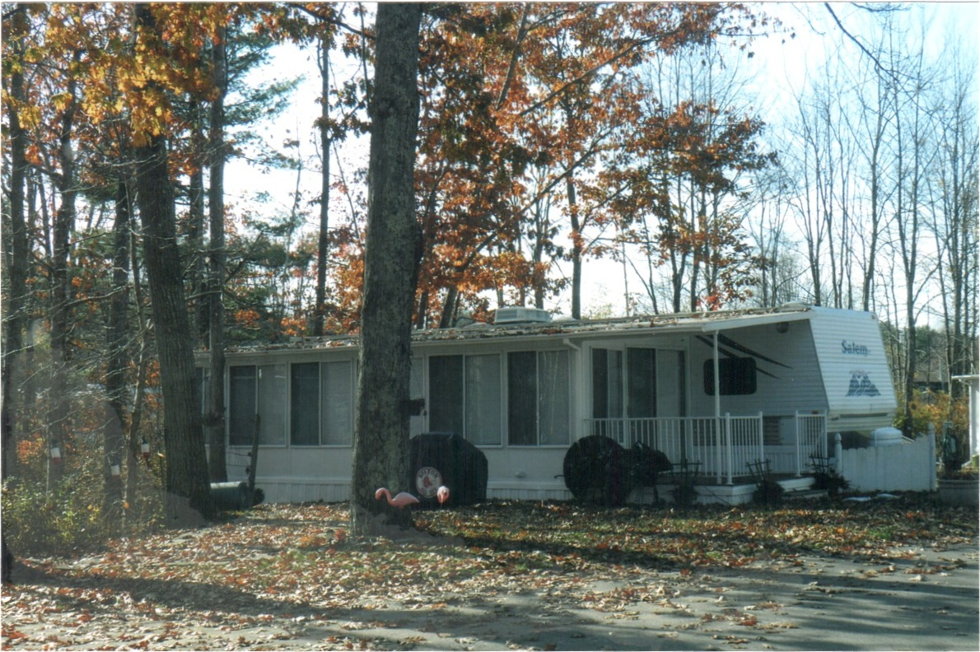
For Sale

Site 70FC
2007 Salem Travel Trailer 39’
- 3-Season Attached Hard Room
- 2 Full Bedrooms (no bunks) New Memory Foam Mattresses
- Central Air and Heat
- Gas Grill
- 8 x 8’ Shed Included
- Beautiful Condition and Well Maintained

Price $12,500
sharen22@aol.com / (508) 756-2493

